**Carlingford High School**

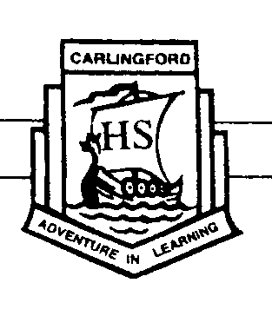

**Mathematics**

**Year 9 (5.1) Term 2 Exam**

**2017**

Name: _____________________________________

*Time allowed: 55 minutes*

* Answer all questions in the spaces provided.
* Marks may be deducted for careless or untidy work.
* Complete the examination in blue or black pen.

|  |  |  |  |  |  |
| --- | --- | --- | --- | --- | --- |
| **Topic** | **The Metric System** | **Perimeter** | **Area** | **Volume** | **Total** |
| **Mark** | **/10** | **/13** | **/20** | **/7** | **/50** |

**The Metric System**

**Question 1**

Convert:

1. 9km = _______________ m
2. 6.4m = _______________ cm
3. 300 hours = _______________ days
4. 75cm = _______________ m
5. 240mm = _______________ cm
6. 8.65 tonnes = _______________ kg
7. 4 years = _______________ months
8. 4900L = _______________ kL
9. 2.03km = _______________ cm
10. ${10m}^{2}$ = ${cm}^{2}$

_______________

**Perimeter**

**Question 2**

Find the perimeter of each shape:

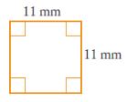Perimeter = ____________ cm

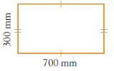

Perimeter = ____________________

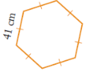 Perimeter = ____________ cm

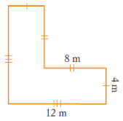

Perimeter = ____________________ m

**Question 3**

Write in the two missing side lengths then calculate the perimeter.

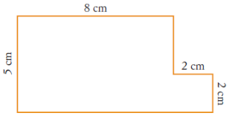

Perimeter = ____________________ cm

**Question 4**

1. A square has perimeter 51cm. Find the length of one side.

Length = ____________________ cm

1. A rectangle has a perimeter of 40cm. If its length is 12cm, find its width.

Width = ____________________ cm

**Question 5**

This shape is made up of a rectangle and an equilateral triangle.

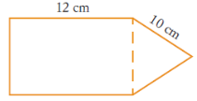

Find its perimeter.

Perimeter = ____________________ cm

**Question 6**

Write a simplified expression for the **perimeter** of each shape.

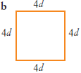

Perimeter = ____________________

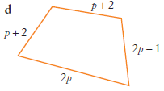

Perimeter = ____________________

**Area**

**Question 7**

Find the area of each shape:

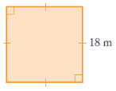

Area = ${cm}^{2}$

__________________

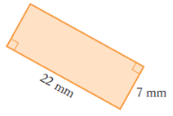

Area = _____________________

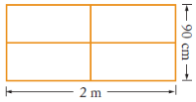

Area = ${cm}^{2}$

__________________

Area = $m^{2}$

__________________

**Question 8**

A square has an area of ${49m}^{2}$. What is the length of one side?

Length = _____________________

**Question 9**

Find the area of each triangle.

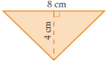

Area = $m^{2}$

__________________

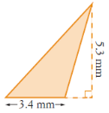

Area = ${mm}^{2}$

_____________________

(c)

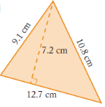

Area = ${cm}^{2}$

__________________

**Question 10**

Write a simplified expression for the **area** of each shape.

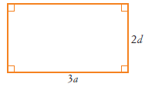

Area = _____________________

(b)

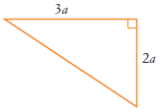

Area = _____________________

(c)

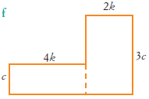

Area = _____________________

**Question 11**

A rectangle has a width of ${2\frac{1}{4}m}^{}$ and an area of ${6\frac{3}{8}m}^{2}$. What is its length?

Length = ____________________ m

**Question 12**

Find the area of each parallelogram.

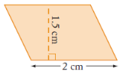

Area = ${cm}^{2}$

__________________

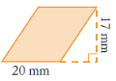

Area = ${mm}^{2}$

__________________

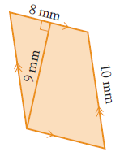

Area = ${mm}^{2}$

__________________

**Question 13**

Find the area of these **composite shapes**.

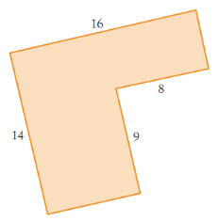

Area = __________________

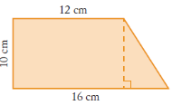

Area = ${cm}^{2}$

__________________

**Volume**

**Question 14**

Find the **volume** of each prism.

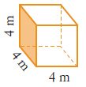

Volume = $m^{3}$

__________________

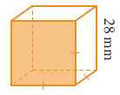

Volume = __________________

(c)

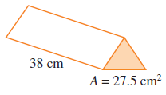

Volume = ${cm}^{3}$

__________________

**Question 15**

The volume of a prism is ${48cm}^{3}$.

Write possible values for the area of the base and the height of the prism.

1. Area of base = ${cm}^{2}$

____________
2. Height of prism = _____________ cm

**Question 16**

Write a simplified expression for the **volume** of this solid.

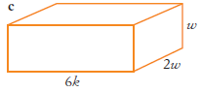

Volume = __________________

**END OF TEST**